**Exploratory Data Analysis of Health Insurance Dataset**

By mustaid ahmed

About the Dataset:

In this project, I delve into a health insurance dataset containing essential information about healthcare coverage and how it affects people. The dataset includes a total of 25,141 records, each representing various aspects of health insurance. These records are a valuable resource for understanding how healthcare utilization, coverage, and outcomes are influenced by different factors.

Understanding the Data:

Year: This numerical variable indicates the year each record belongs to, providing a sense of time.

FIPS: FIPS codes, another numerical feature, help me uniquely identify geographical regions.

State FIPS: Similar to 'FIPS,' this number helps me recognize state-level geographical distinctions.

County FIPS: Similar to the above, but focusing on county-level geographical data.

County Name: A text field holding the names of counties, giving me geographical context.

State Name: This textual feature tells me the names of the states, helping me analyze on a state-level basis.

State Abbreviation: A handy text field with state name abbreviations, making data interpretation easier.

Metro/Non-Metro: This text feature likely tells me whether an area is metropolitan or nonmetropolitan, which affects healthcare accessibility.

Uninsured: An important numerical feature representing the number of uninsured individuals, a critical metric in understanding healthcare coverage.

Population (18 to 64): This numerical variable lets me know the population of people aged 18 to 64, offering demographic insights.

Purpose of My Study:

In this project, my aim is to delve into the health insurance dataset and uncover patterns, relationships, and trends that shed light on how healthcare coverage affects individuals. Through data visualization, statistical analysis, and data exploration, I hope to gain insights into the dynamics of health insurance and its impact on people's well-being.

Tools and Methods:

As a student embarking on this project, I am using Python and its libraries, such as Pandas, NumPy, and Seaborn, to conduct data manipulation, visualization, and statistical analysis. My analysis will include exploring the dataset's descriptive statistics, distributions, and correlations to discover meaningful findings.

By conducting this exploratory data analysis, I aim to contribute to a better understanding of the health insurance landscape and its impact on individuals' experiences with healthcare.

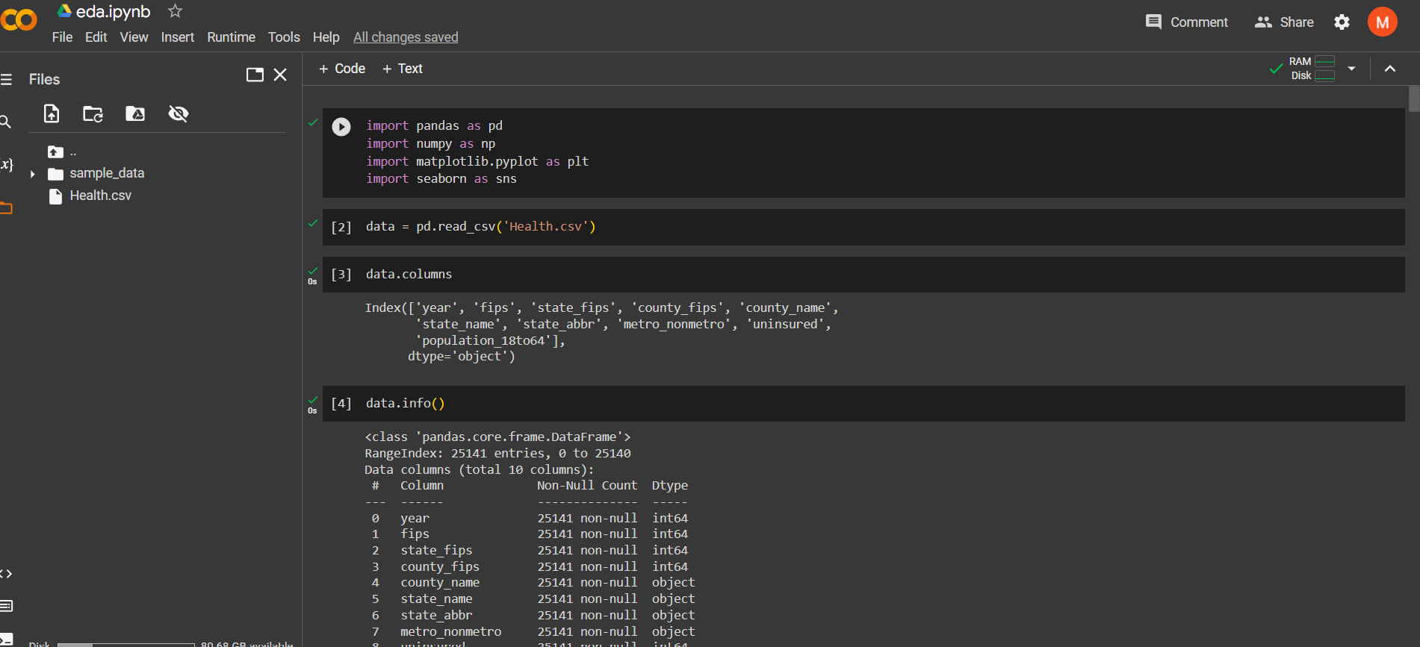 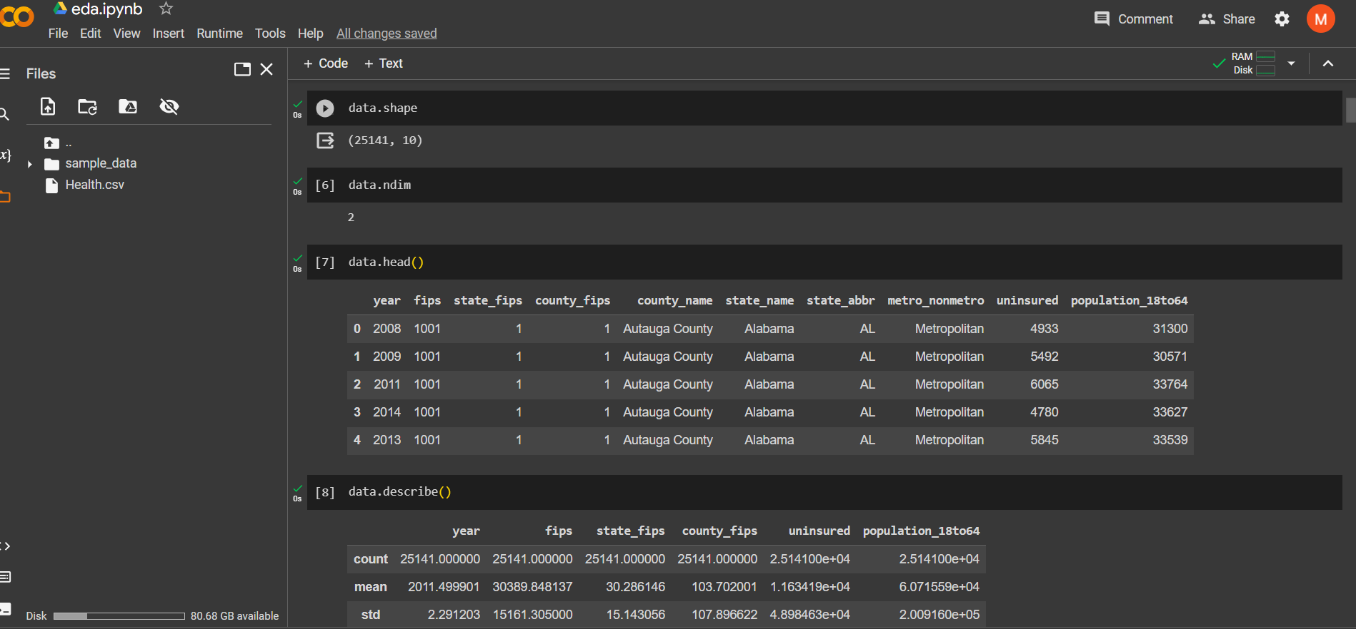

Codes for importing libraries and uploading CSV file into colab. And using sum functions .

Reading CSV file code and its output.

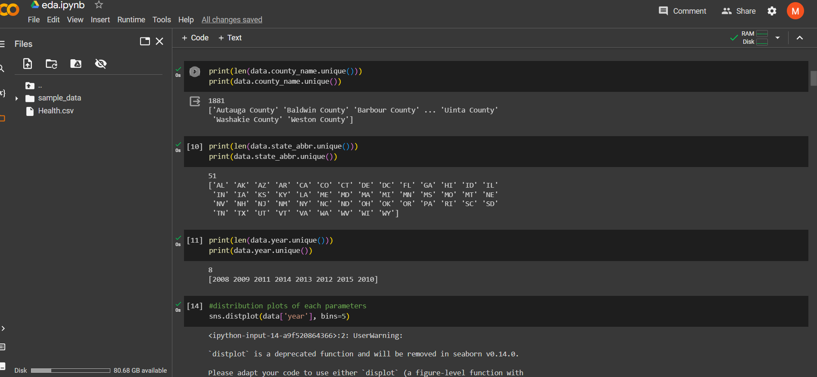 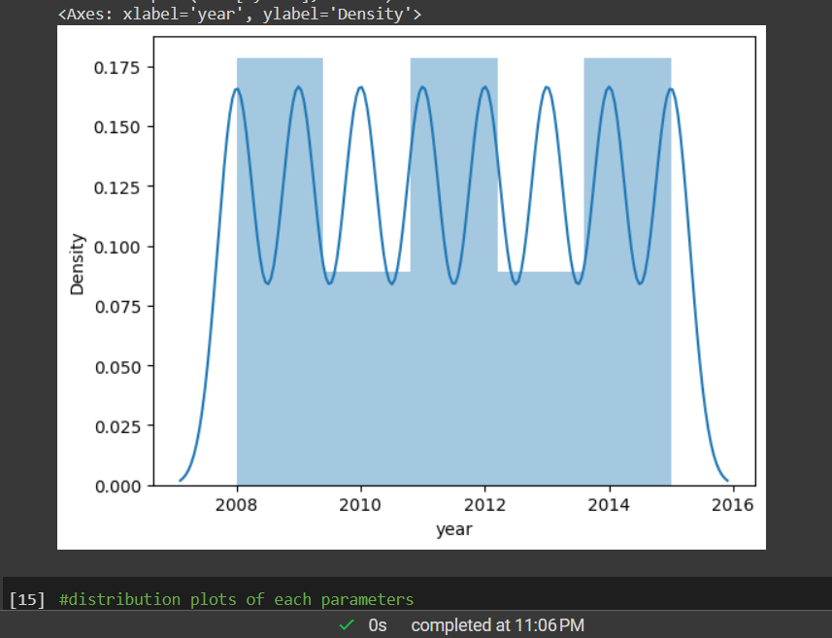

The density plot graph in the image depicts variations over the years from 2000 to 2016. Here are the key takeaways:

Cyclic Trends: The blue line oscillates, forming peaks and troughs. This suggests a cyclic or periodic trend in the data.

Yearly Patterns: The density values exhibit recurring patterns, possibly corresponding to seasonal or annual changes.

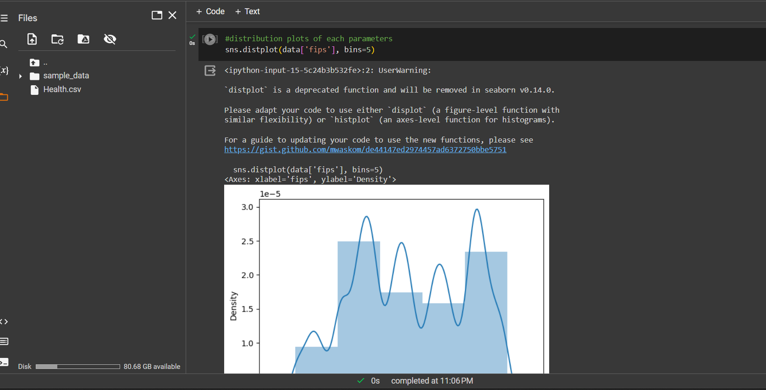 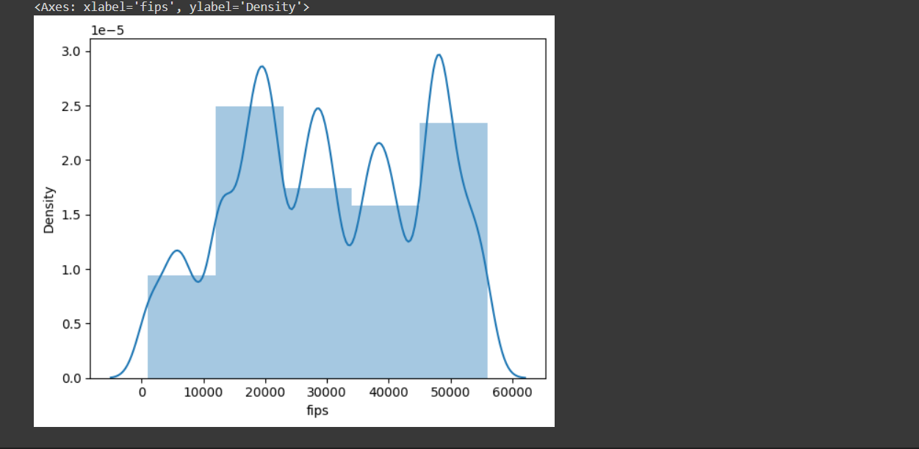

The density plot represents the population density over the years from 2000 to 2016. Let’s delve into the interpretation:

Cyclic Patterns: The oscillations in the blue line suggest recurring patterns. These could correspond to seasonal variations or other cyclic trends in population density.

Yearly Fluctuations: Peaks and troughs indicate changes in population density. Higher peaks may represent periods of growth or increased urbanization, while troughs could signify migration or other factors affecting density.

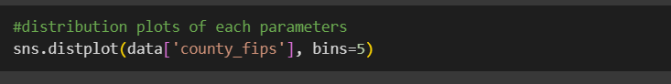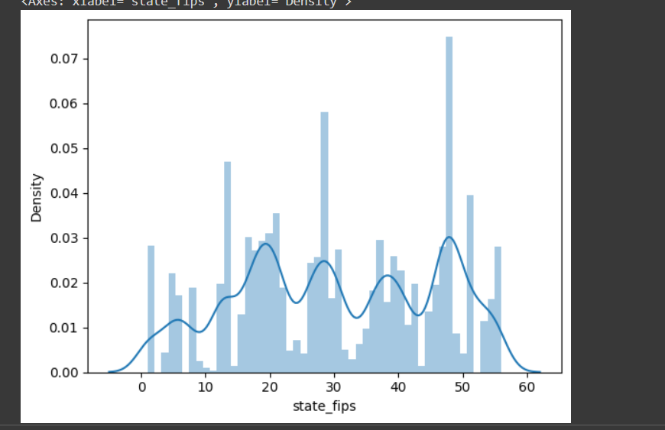 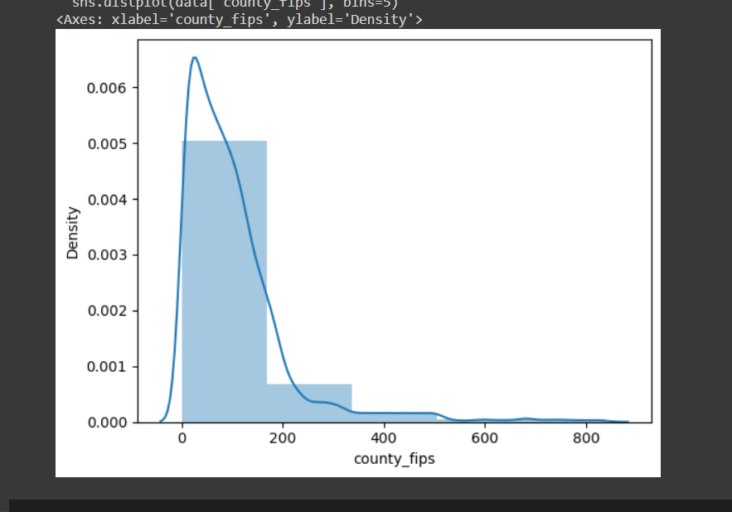

The density plot graph represents the population density across different state regions. Here are the key takeaways:

Cyclic Patterns: The blue line exhibits oscillations, suggesting recurring trends in population density. These cycles may correspond to seasonal variations or other periodic factors.

Peaks and Troughs: Notable peaks occur around specific state_fips values (approximately 5, 25, and 45). These peaks indicate areas with higher population density.

